Project Design Phase-II
Data Flow Diagram & User Stories

Date | 15 October 2022
Team ID | PNT2022TMID47537
Project Name | Project - A Novel Method for Handwritten Digit Recognition System.
Maximum Marks | 4 Marks

Data Flow Diagrams:
A Data Flow Diagram (DFD) is a traditional visual representation of the information flows within a system. A neat and clear DFD can depict the right amount of the system requirement graphically. It shows how data enters and leaves the system, what changes the information, and where data is stored.

Example:
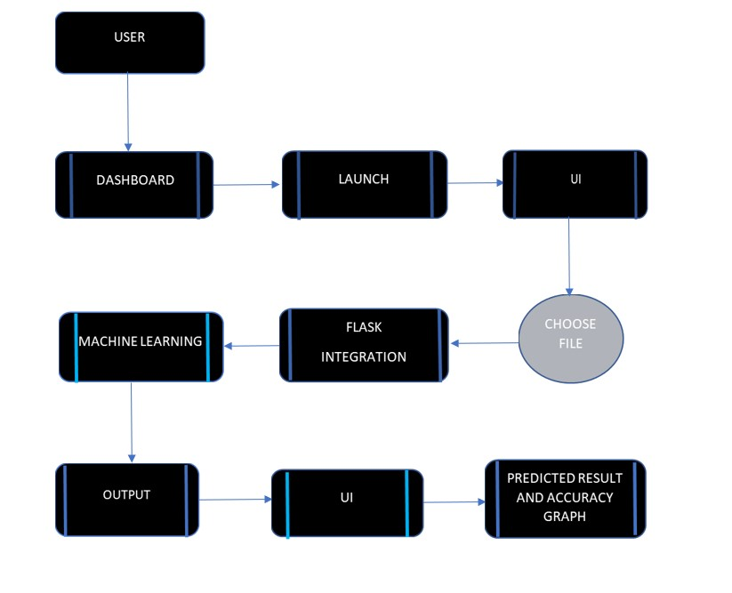

User Stories
Use the below template to list all the user stories for the product.
User Type | Functional  Requirement  (Epic) | User  Story  Number | User Story / Task | Acceptance criteria | Priority | Release
Customer | Dashboard | USN-1 | As a user, they can see the information regarding the prediction of handwritten digit recognition. | I can see the information regarding digit recognition. | High | Sprint 1
 | Launch | USN-2 | On clicking the launch button, it will redirect the user to a page where the images to be predicted can be uploaded. | I can see the launch button. | High | Sprint 1
 | Upload | USN-3 | Users can select the image from the local storage. | I can upload the image. | High | Sprint 2
 | Predict | USN-4 | Once the image is uploaded, it will predict the respective image. |  | High | Sprint 3
 | Display | USN-5 | The predicted image will be displayed with the accuracy chart. | I can see the result with accuracy. | High | Sprint 4

